**Purdue English Writing 2577  
ISTM Spring Semester 2023 Class date: Feb 22/ Week 2  
Instructor: Mark Custance**

Task 1 Review and practice

What are the 3 components of Task 1?

1.

2.

3.

Look at this graph and answer the questions.

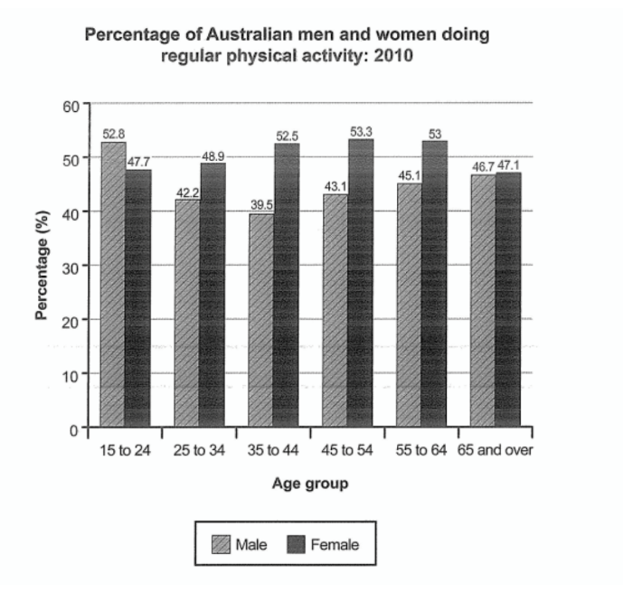

1. What was the overall percentage (i.e. average or range) of ***all Australian men and women*** who did regular physical activity in 2010?
2. Are there any differences between the figures for men and women, looking at ***all age groups***?
3. Were any age groups noticeably more (or less) active than the others?

**Remember:** Most IELTS candidates fail to write a good overview of the information in writing task 1. We need to practise looking at the 'big picture'.

**Overview: Further practice**

|  |
| --- |
|  |

One of the most important things about the Academic Task 1, be it a process diagram, map, graph, bar chart or table, is to **write an overview**.

The overview describes the overall picture of what you see, so it often appears **after the introduction**.

Use a linking word or phrase to signal to the examiner that this is your overview. **Try to mention at least 2 things.**

**Overall,** it can be clearly seen that the total numbers of people employed have increased over the period, whereas the number of women employed has decreased.

**It is clear that** Germany was the major producer of vehicles over this period followed by France and then Norway.

These overviews **do NOT include data or figures**, only a summary of what you see - the most noticeable features.

In this practice exercise, I want you to take a look at the graph below and write your own **overview** (**not a response to the whole graph, just the overview**).

**Mention 2 things:**

**1. rates revenue/user charges = increased**

**2. borrowings/grants and subsidies = fluctuated, but remained about the same/did not change much**

Begin: **It is clear that/ Overall,….**

**The line graph shows the finances for a local authority in New Zealand.**

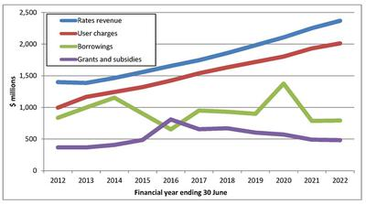

**Key features practice:**

The graph below shows the consumption of four types of dairy products in the USA from 1970 to 2010.

[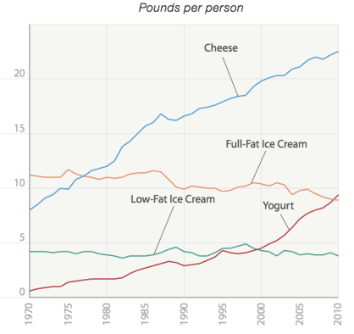](https://i0.wp.com/ieltsliz.com/wp-content/uploads/2015/02/cheese-dairy-consumption-graph.png)

**Questions 1-6**

Complete the details using no more than three words for each gap.

The amount of cheese eaten by people from the USA (1)…………….. (2)…………………….. from about 7 pounds in 1970 to reach a (3)…………… of over 20 pounds in 2010. Likewise, the consumption of yoghurt (4)………………. from just over 0 to just under 10 pounds in the final year. There was (5)………………… in the amount of full-fat ice cream eaten of about 2 pounds to reach about 9 pounds in 2010. The consumption of low-fat ice cream(6) …………. at around 4 pounds over the period given.

**Classroom Writing Exercise**

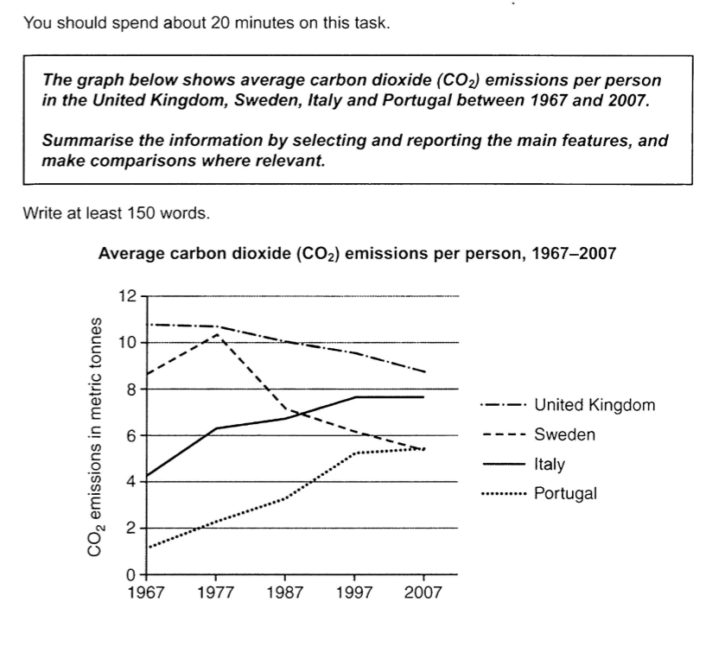

**Writing an IELTS Essay Introduction:** [**https://www.youtube.com/watch?v=kTZkncOJifU&t=52s**](https://www.youtube.com/watch?v=kTZkncOJifU&t=52s)

Watch this short video on IELTS essay introductions and answer these questions:

A. What are the 2 main things you should do?

1.

2.

B. How many sentences should you write?

In the writing for task 2, you must write an **IELTS essay introduction**, but you only have 40 minutes.

In this time you need to **analyze the question**,**brainstorm** ideas to write about, formulate an essay**plan**, and then **write** your response.

Your **paragraphs** are the **most important thing** as they contain all your supporting arguments and demonstrate how good you are at organizing your ideas.

You therefore need a method to write your IELTS essay introduction fairly quickly. When you write an introduction, you should make sure you do two things:

1. *Write a sentence****introducing the topic****and giving some****background facts****about it*
2. *Tell the reader****what you are going to be writing about***

How you do this will vary depending on the question, but here is an example:

**Example 1:**

Question:

***Blood sports have become a hot topic for debate in recent years. As society develops it is increasingly seen as an uncivilized activity and cruel to the helpless animals that are killed. Blood sports should be banned.***

***To what extent to you agree or disagree?***

**Sample IELTS essay introduction: 2 sentences**

*Despite the fact that****killing animals for sport****is popular in modern society, it remains a contentious issue.* ***I believe that*** *blood sports are cruel and uncivilized and so should be banned as soon as possible.*

As you can see, the **first sentence** consists of the**topic** plus some **background facts** on the topic which have been taken from the rubric. The**second sentence**then gives the **writers opinion** and tells us that in the essay the writer will be arguing the reasons why it is cruel.

You must always have a **thesis/position** statement

**Paraphrasing**

Another important point - **don't copy from the question!**You must paraphrase (put it in your own words). Using some of the same words is acceptable, but **don't copy whole phrases**.

You can see how the question above has been paraphrased. All the information is from the question, but it has been written in a different way and has not been copied.

**Now try with this question. Write the introduction: 2 or 3 sentences**

**Question:**

***According to a recent study, the more time people use the Internet, the less time they spend with real human beings. Some people say that instead of seeing the Internet as a way of opening up new communication possibilities worldwide, we should be concerned about the effect this is having on social interaction.***

***Do you agree or disagree with this opinion?***

**Improving Essay Coherency & Cohesion**  
You need to make sure your ideas flow well from paragraph to paragraph and within each paragraph.  
Take a look at this essay. **Six of the sentences are missing but they are below the essay.**Your job is to place the sentences in the correct place in the essay.

**Matching Sentences Exercise**  
***Some people believe that educational qualifications will always bring success in life. Other people say that educational qualifications do not necessarily bring success.  
Discuss both views and give your opinion***

Some people find academic degrees or other training essential milestones for future success, while others believe that this does not guarantee future success and there are other success factors just as crucial. (1) ____________________________________.   
(2) ____________________________________. With regards to a career, it makes a person more competitive as employers will generally seek people who are well-qualified for the best and most richly rewarded positions in their company. This is true for all types of work, be it as an accountant or lawyer or work in the building trade. (3) ____________________________________, as for some gaining more educational qualifications is not for work but instead leads to a sense of personal accomplishment and fulfillment.  
(4) ____________________________________. In terms of work, many people study hard to become well qualified for but then fail to reach the heights of success that they expected. This is because in today’s world there is a high level of competition for many jobs and a high number of graduates or qualified people. (5) ____________________________________. ‘People skills’ are also very important and regardless of the level of qualifications, those who cannot get along well with others may be less likely to achieve the success they desire.  
(6) ____________________________________. Other factors such as the current job market and personal skills are also factors of importance.

**Place these missing sentences into the essay. The words in bold should provide a clue to identify where they should go.** *A.* ***On the other hand****, it is not certain that success will follow.  
B.* ***Not only this****, there are other skills needed aside from qualifications.  
C.* ***On the one hand,*** *gaining educational qualifications is certainly a method with which to gain success in certain areas of life.  
D.* ***To conclude****, therefore, educational qualifications can bring success in life for many people, yet there are no guarantees this will be the case.  
E.* ***Personally****, I take the opinion that success is not guaranteed.   
F.* ***It can also****be viewed as bringing success in terms of one’s own development…*

**IELTS Conclusion Quick Tips**

1. **Never write any new ideas in your conclusion.**A conclusion should always simply restate the ideas you have in the rest of the essay. New ideas should be in the main body and not in the conclusion.
2. **Make sure you answer the question in the conclusion.** Rewrite your position.
3. **Don’t try to include everything**: just **summarise your main points**.
4. **Always write one: Begin: In conclusion or To conclude,**

Now write **the 2 body paragraphs and the conclusion** for the internet question above. Use this model to help you.